**Splitting The Pitch Into Four:**

1. 1st pole = P1
2. 2nd pole = P2
3. 1st middle of pitch = M1
4. 2nd middle of pitch = M2
5. 3rd middle of pitch = M3

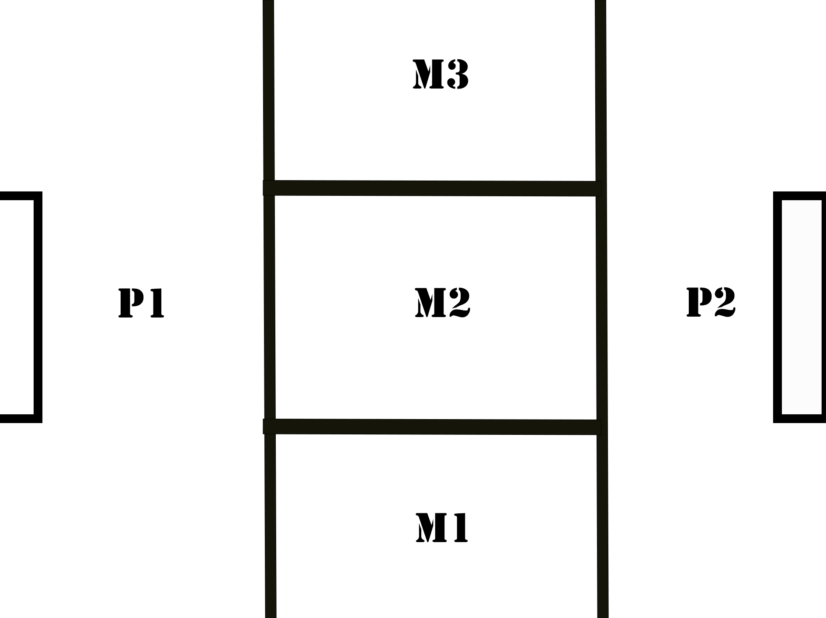

**Slots Reserved For Training For Respective Teams**

|  |  |  |  |  |  |
| --- | --- | --- | --- | --- | --- |
| DAYS | P1 | P2 | M1 | M2 | M3 |
| Monday | Kasanoma-Boys | Elite-Girls | Kasanoma-Girls | Northside-Girls | Highlanders |
| Tuesday | Northside-Boys | Red Army-Girls | Elite-Boys | Legends | Red Army-Boys |
| Wednesday | Northside-Girls | Kasanoma-Girls | Northside-Boys | Kasanoma-Boys | Elite-Girls |
| Thursday | Elite-Boys | Red Army-Boys | Legends | Red Army-Girls | Highlanders |

NB: From the table above, only 8 teams out of 10 have the chance to use the big pole at least once a week. The big poles were given out based on a ‘first come first served’ condition. Highlanders and Legends were unfortunate to come last hence, they must train with the smaller poles each week due to limited spots for the big pole.

This is the official AFA training schedule for all AFA club teams. Teams should only train on the days they are scheduled for. However, teams are free to train on weekends. For that, AFA leaves it to their discretion.